TESTING – Launching accuracy

Project: Design an Autonomous Robot

Task: To design an autonomous robot that is capable of navigating to a predetermined position while avoiding obstacles and firing objects at two targets. This is to be done in the shortest time possible.

Document Version Number: 1.0

Date: March 12th

Tester: Yu Chen Xu

Software Version: 1.0

Hardware Version: 2.0

Goal: The goal of this test is to know the accuracy of the launcher and the average distance achieved by the ball, as well as to test the loading effectiveness.

Table of Contents

PURPOSE 3

OBJECTIVES 3

PROCEDURE 3

EXPECTED RESULTS 3

FORMAT OF OUTPUT REQUIRED 4

SAMPLE CALCULATIONS 4

TEST REPORT 4

CONCLUSION 5

ACTION 5

DISTRIBUTION 5

# PURPOSE

The purpose of the test is to know how far the ball can reach. This information is important as it will help to determine where the robot shooting position will be at in the competition. This test is also made to know the accuracy of the landing spots, so that it might be improved if there is a big range of error.

This test will be done with the hardware version 2.0 and a testing code that can be found in the “Launching test” folder.

Another purpose of the test is to verify if the loading system is working or not. Its functionality is essential for the competition.

# OBJECTIVES

The objective of the test is to know if the launcher can work properly and to know the distance the ball can travel. Those information are essential to find out the optimal shooting spot on the enclosure.

This test is a simulation of the shooting part of the competition. Since the competition will be held at an indoor place, there will not be any factors that affect the launching of ball. Therefore, it is correct to assume that doing the test in the lab room can represent well the real situation.

# PROCEDURE

1. Place the robot at a position (0, 0) (i.e.: at an intersection of the grids).
2. Launch a Ping-Pong ball along with the loading mechanism.
3. Measure the X and Y components.
4. Repeat step 2) and 3) 15 times.

# EXPECTED RESULTS

The expected result is that the ball will land near (0, 90). In the competition, the targets will be at 30cm and 60cm from the edges of the top-right square tiles. Shooting at the limits of the edges wouldn’t be a best option, because the robot might go out of the restricted zone when it turns. So, having a 90cm projection will leave the robot more freedom.

The best case of the test is that the ball will land near (0, 90) with a 10 cm radius error in more than 75% of the cases. This will prove the accuracy and the exactness of the launcher. The worst case scenario of the test would be that the landing spot is more than 15cm far from the desired point (0, 90) in 75% of the trials.

As for the loading system, it is expected that it can load balls without human intervention.

# FORMAT OF OUTPUT REQUIRED

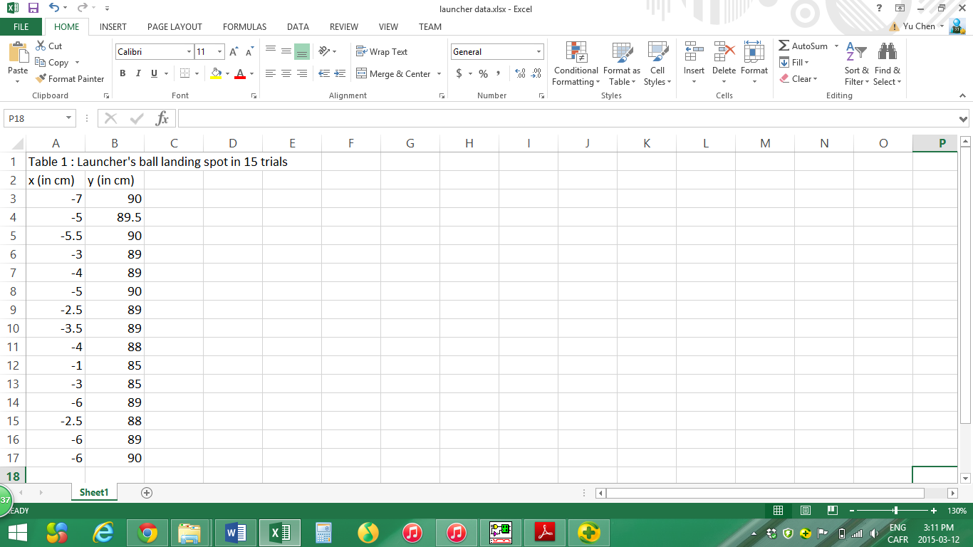

This table can be found in the “Launcher data.xlsx”.

# SAMPLE CALCULATIONS

The mean value can be obtained by the following formula: $μ=\frac{1}{N}\sum_{i=1}^{N}{Xi}$

EX: For X-axis mean, $μ= \frac{\left(-7\right)+\left(-5\right)+\left(-5.5\right)+…+\left(-2.5\right)+\left(-6\right)+(-6)}{15}= -4.27$

In this test, the mean values for x-axis and y-axis are respectively -4.27 and 88.63 cm.

The standard deviation can be obtained as $σ= \sqrt{\frac{\sum_{i=1}^{N}{({Xi-μ)}^{2}}}{N-1}}$

In this test, the standard deviation for x-axis and y-axis are respectively 1.69 and 1.61 cm.

# TEST REPORT

The collected results are very positive as the launcher can be considered accurate, as shown by the standard deviation values, 1.69 and 1.61 cm for each axis respectively. On the y-axis, the results are very ideal as, in 100% of the time, the ball landed within a 5cm error range. Even more surprising, in 85% of the time, the ball landed between 88 and 90 cm, which is a small error range. However, on the x-axis, the ball landed on average on the left of the point (0, 90) by 4.27cm, which is slightly bigger than y-axis’ mean value. As observed, the landing spot is always on the negative side of the x-axis. Therefore, it means that the ball does not travel in straight line, but a slightly angled trajectory.

As for the loading system, it doesn’t have any problems.

# CONCLUSION

This testing can be considered “passed” as the observed output is closed to the expected results. On each axis, the ball always landed within a 10 cm radius. However, the average error is bigger on x-axis than on y-axis. Therefore, to correct this problem, the robot can be initially placed with a small angle to the right of the y-axis (e.g. 1º). Last, the loading system works well.

# ACTION

This test report should be keep within the mechanical team in order to bring adjustments to the launcher in the future.

# DISTRIBUTION

This testing belongs to the mechanical development.